.NET TECHNOLOGIES (01CE1523)
Lab Manual

Name: Priyanshu Kapadiya
Enrolment No: 92400103232
Class:5EC2
Batch:A

INDEX

Lab | Program | CO | Date | Marks |  |  |  | Total | Signature
 |  |  |  | R1(4) | R2(2) | R3(2) | R4(2) | (10)
1. | Develop Student Admission Management Module using OOP Concepts (Class, Object, Constructor, Access Modifiers). | CO1
2. | Design Employee Payroll System using Inheritance, Interface & Polymorphism | CO1
3. | Develop Expense Tracking Module with Exception Handling | CO1
4. | Build Online Event Registration Portal using ASP.NET Controls & Validation | CO2
5. | Develop Academic Calendar & Leave Management System using Rich Controls, Session & Cookies | CO2
6. | Create Product Catalog Application using ASP.NET MVC Architecture. (Controllers, Models, Views, Routing) | CO3
7. | Develop Feedback Management Module using MVC Layout, Partial View & Validation. (HTML Helpers, Validation, Layouts) | CO3
8. | Develop Inventory Management Module using ADO.NET & CRUD Operations | CO4
9. | Create Placement Dashboard using Data Controls & Crystal Reports | CO4
10. | Build Student Management REST API using ASP.NET Core  (Middleware, API, Project Structure) | CO5
11. | Develop Smart Campus Service Portal – Feature Extension  (Integrate MVC + Database + API) | CO1,  CO2,  CO3,  CO4,  CO5

R1 | Practical Performance
R2 | Timely Submission
R3 | Neatness & Documentation
R4 | Uploaded on Git

Experiment 1
AIM: Develop Student Admission Management Module using OOP Concepts (Class, Object, Constructor, Access Modifiers).
Source: StudentAdmissionManagement.cs
Code:
using System;
namespace StudentAdmissionSystem
{
class Student
{
private int id;
private string name;
private string course;
private double fees;
public Student(int id, string name, string course, double fees)
{
this.id = id;
this.name = name;
this.course = course;
this.fees = fees;
}

public void DisplayDetails()
{
Console.WriteLine("------ Student Admission Details ------");
Console.WriteLine("Student ID : " + id);
Console.WriteLine("Student Name : " + name);
Console.WriteLine("Course : " + course);
Console.WriteLine("Fees : " + fees);
}
}

class Program
{
static void Main(string[] args)
{
Student s1 = new Student(101, "John Smith", "Computer Science", 50000);
Student s2 = new Student(102, "Emma Watson", "Information Technology", 45000);

s1.DisplayDetails();
s2.DisplayDetails();

Console.ReadKey();
}
}
}

Output: Screenshot:

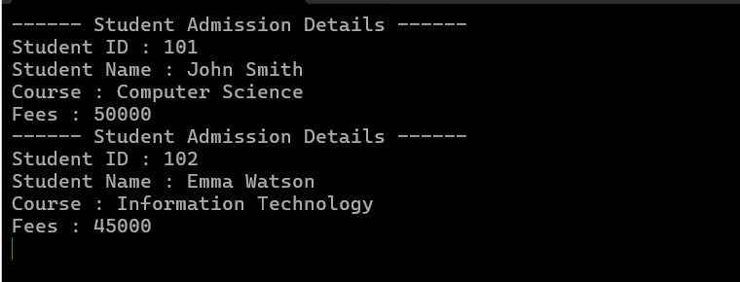

GitHub URL:
https://github.com/priyanshuk0777/Practical-1.git

